SULIT



SECP2523 DATABASE

SESSION 2024/2025 - SEMESTER 1
````

ALTERNATIVE ASSESSMENT REPORT: PHASE 1

Name | WOO CHENG SHUAN
IC No. / Matric No. | 040221-08-0056 / A23CS0283
Year / Program | 2/SECPH
Section | 01
Lecturer Name | DR. ROZILAWATI BINTI DOLLAH
Case Study | WBL PROJECT
System Name | KOPERASI KADA SYSTEM
Group Name | TECHNICRAB

SECTION A (SYSTEM’S OVERVIEW)

1.1 | Overall Description
 |  | << Describe the system’s overview. >>
1.2 | Project Weaknesses or Improvement
 |  | << List the project’s weaknesses or improvement that can be made to the proposed system. Provide an explanation of the proposed module to overcome the weaknesses. >>
1.3 | Proposed Module
 |  | << Describe a new module to overcome the project’s weaknesses. >>
SECTION B (DATABASE PLANNING AND DESIGN)

2.1 | Conceptual ERD
 |  | << Draw a conceptual ERD to represent the proposed module. >>
2.2 | Logical ERD
 |  | <<Provide logical ERD of your module in the proposed system.>>
2.3 | Data Dictionary for Logical ERD
 |  | << Provide the data dictionary based on the logical ERD in Subsection 2.2.>>
2.4 | Relational Database Schema
 |  | <<Provide all relations database schema of your proposed module.>>
2.5 | Normalization
 |  | << Illustrate the normalization process up until BCNF to every relation listed in 2.5. At the end of this section, list all normalized relations achieved. >>

Table of Contents
Section A: System Overview 4
1.1 Overview Description 4
1.2 Project Weakness or Improvement 4
1.3 Proposed Module 5
Section B: Database Planning and Design 6
2.1 Conceptual ERD 6
2.2 Logical ERD 7
2.3 Data Dictionary for Logical ERD 7
2.4 Relational Database Schema 12
2.5 Normalization 13

Section A: System Overview

1.1 Overview Description

The Koperasi KADA system is to create a fully integrated digital platform that enhances the efficiency, security and user experience for all members and administrators. The system is a web-based platform that designed to digitize and optimize the internal processes of Koperasi KADA. It focuses on member registration, loan applications and financial management. This system provides an integrated interface for members and administrators to enable seamless interaction and process automation.

The system enables prospective employees to register online, submit required documents and track their application status in real time. The approved members can access additional features such as applying for loans, managing savings and viewing financial statements. Meanwhile, the system centralizes member and loan data for administrators by allowing them to process with applications, approve or reject member registration and loan requests. In the system, the administrators also can generate comprehensive reports efficiently. The automated workflows and secure data handling can minimize human error and reduce dependency on manual paperwork.

The Koperasi KADA system is a user-friendly interface and role-based access controls ensure that different roles of user can navigate the system effortlessly while accessing only the functionalities pertinent to their role. Overall, the system serves as a transformative tool, fostering increased productivity, improved service delivery and enhanced member satisfaction through its efficient, secure and integrated platform.

Group Member’s Name | Matric No | Module
Lau Yee Wen | A23CS0099 | Employee Module (apply membership and view membership application status)
Chau Ying Jia | A23CS0213 | Member Module (apply for loan and view loan application status)
Cheryl Cheong Kah Voon | A23CS0060 | Member Module (view financial status and manage profile)
Neo Li Xin | A23CS0253 | Admin Module (generate reports)

1.2 Project Weakness or Improvement

The system currently lacks a robust automated alert mechanism to notify administrators about pending registration and loan application approvals. This deficiency increases the risk of important tasks being overlooked or delayed, particularly when administrators manage a high volume of applications. Without timely alerts, administrators may miss critical deadlines, leading to prolonged waiting periods for applicants. This delay can cause frustration among applicants, as they are left uncertain about the status of their requests.

1.3 Proposed Module

Based on the answer in Section A(2), the new module to overcome the weaknesses is an automated notification and alert system. This module aims to introduce automated notifications and alerts for both administrators, users and members. It ensures timely updates and efficient communication between all stakeholders involved in the registration and loan application process.

The system will send reminders to administrators about pending approvals for registrations and loan applications automatically after a setting period. Meanwhile, the system will notify users or members immediately when their registration or loan application status changes or requires additional information. The notification can provide detailed instructions in notifications if further actions are needed. The notification and alert can be sent via email, SMS or an in-system notification panel.

Section B: Database Planning and Design

2.1 Conceptual ERD
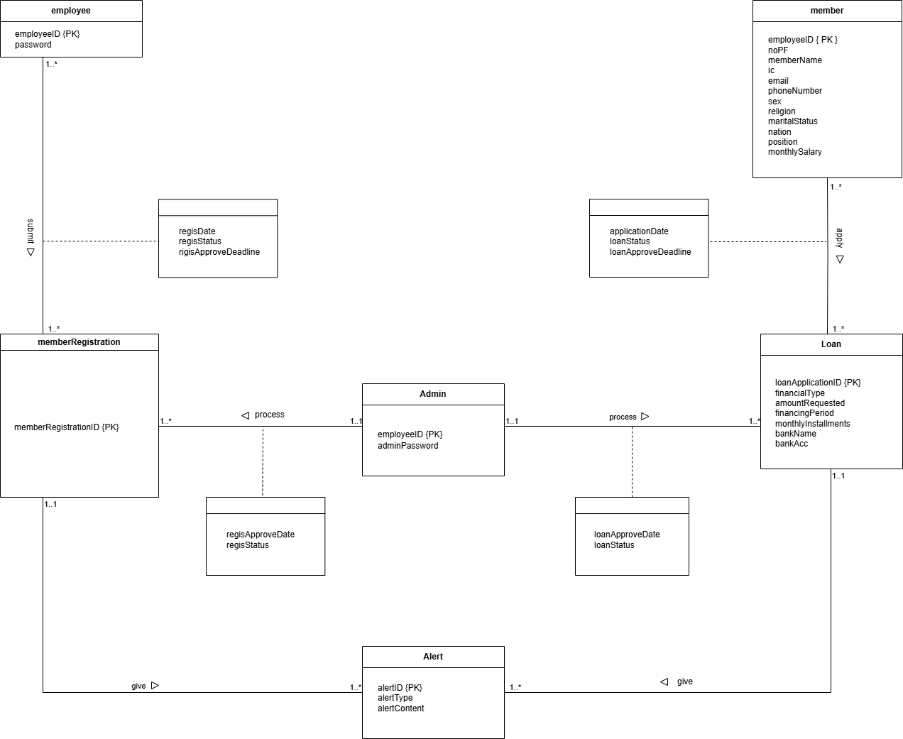

2.2 Logical ERD
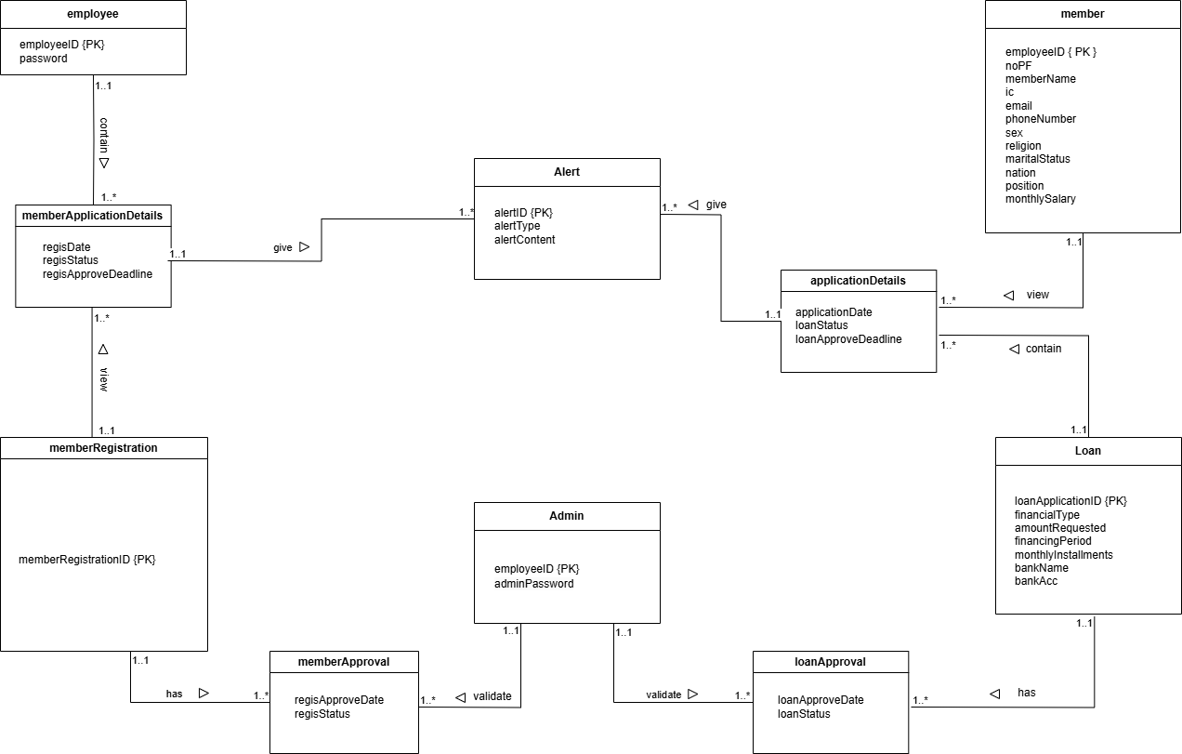

2.3 Data Dictionary for Logical ERD

2.3.1 Identifying Entity

Entity Name | Description | Aliases | Occurrence
Employee | Represents any person accessing the KADA system | New user, guest | Occurs when first-time user visit the website
Member | Represents registered users who have created KADA accounts | Members | Occurs when new user or guest register as a member
Admin | Represents the system admin who responsible for managing KADA system | Administrator, staff | Occurs when system built and processing members’ account activity
memberRegistration | Describe all activities when a user register as a member | Users | Occurs when a new user register as a member through KADA system
memberApplication Details | Contains detailed information about the member’s registration application | Registration details | Occurs when a member fills out detailed information during the registration process
memberApproval | Represents the approval process for member registrations | Registration approval | Occurs when the admin approves or rejects a member’s registration
Loan | Represents loan applications submitted by members | Loan application record | Occurs when member apply for loan
applicationDetails | Contains detailed information about the member’s loan application | Loan application details | Occurs when a member submits all required information for a loan application
loanApproval | Represents the approval process for loans submitted by members | Loan approval process | Occurs when the admin approves or rejects a loan application
alert | Represents automated alerts sent to admins | System alerts, reminder | Occurs when pending approvals or deadlines require action within a set period

2.3.2 Identifying Relationship Types

Entity Name | Multiplicity | Relationship | Entity Name | Multiplicity
Employee | 1..1 | contain | memberApplicationDetails | 1..*
Member | 1..1 | view | applicationDetails | 1..*
Admin | 1..1  1..1 | Validate  validate | memberApproval  loanApproval | 1..*  1..*
memberRegistration | 1..1  1..1 | View  has | memberApplicationDetails  memberApproval | 1..*  1..*
Loan | 1..1  1..1 | Contain  has | applicationDetails  loanApproval | 1..*  1..*
memberApplicationDetails | 1..1 | give | alert | 1..*
applicationDetails | 1..1 | give | alert | 1..*

2.3.3 Attributes Description

Entity Name | Attributes | Data Type & Length | Description | Nulls | Multi-  valued | Example
Employee | employeeID (PK) | INT (4) | Unique ID for the user | No | No | 1234
 | password | VARCHAR (30) | User’s account password | No | No | P12345W@@
Member | employeeID (PK) | INT (4) | Unique ID for member | No | No | M0000001
 | noPF | INT (4) | Unique PF number for member | No | No | 1234
 | memberName | VARCHAR (80) | Name of the member | No | No | Ali Abu
 | ic | CHAR (12) | Identification number of the member | No | No | 040101081234
 | email | VARCHAR (30) | Member’s email address | No | No | member@gmail.com
 | phoneNumber | VARCHAR (15) | Contact number of the member | No | No | +60123456789
 | sex | CHAR (1) | Gender of the member (M/F) | No | No | F
 | religion | VARCHAR (30) | Religion of the member | Yes | No | Buddha
 | maritalStatus | VARCHAR (15) | Marital status | Yes | No | Single
 | nation | VARCHAR (30) | Nationality of the member | Yes | No | Malaysia
 | position | VARCHAR (30) | Working position of the member | No | No | Data Engineer
 | monthlySalary | DECIMAL (10,2) | Member’s monthly salary | No | No | 10000.00
Admin | employeeID (PK) | INT (4) | Unique ID for admin | No | No | 1234
 | adminPassword | VARCHAR (30) | User’s account password | No | No | P12345W@@
memberRegistration | memberRegistrationID (PK) | VARCHAR (20) | Unique ID for member registration | No | No | MR123456789
memberApplicationDetails | regisDate | DATE | Date of member application submission | No | No | 15-01-2025
 | regisStatus | VARCHAR (20) | Member registration status | No | No | Pending
 | regisApproveDeadline | DATE | Deadline for admin approval | No | No | 25-01-2025
memberApproval | regisApproveDate | DATE | Date of member registration approval | No | No | 15-01-2025
 | regisStatus | VARCHAR (20) | Member registration status | No | No | Approved
loan | loanApplicationID (PK) | VARCHAR (20) | Unique ID for loan application | No | No | LA123456789
 | financialType | VARCHAR (30) | Type of financing | No | No | Personal Loan
 | amountRequested | DECIMAL (12,2) | Amount requested for the loan | No | No | 30000.00
 | financingPeriod | INT | Loan repayment period in months | No | No | 24
 | monthlyInstallments | DECIMAL (10,2) | Monthly repayment amount | No | No | 650.00
 | bankName | TEXT | Name of the bank | No | No | Maybank
 | bankAcc | INT | Bank account number | No | No | 123456789
applicationDetails | applicationDate | DATE | Date of loan application submission | No | No | 15-01-2025
 | loanStatus | VARCHAR (20) | Status of the loan application | No | No | Pending
 | loanApproveDeadline | DATE | Deadline for admin approval | No | No | 25-01-2025
loanApproval | loanApproveDate | DATE | Date of loan application approval | No | No | 15-01-2025
 | loanStatus | VARCHAR (20) | Status of loan application | No | No | Approved
alert | alertID | VARCHAR (20) | Unique ID for alerts | No | No | 200001
 | alertType | VARCHAR (20) | Type of alert | No | No | Deadline reminder
 | alertContent | TEXT | Content of the alert | No | No | Your registration validate deadline is approaching.

2.4 Relational Database Schema

EMPLOYEE (employerID, password)
PK: employeeID

ADMIN (employeeID, adminPassword)
PK: employeeID
FK: employeeID references EMPLOYEE (employeeID)

MEMBER (employeeID, noPF, memberName, ic, email, phoneNumber, sex, religion, maritalStatus, nation, monthlySalary)
PK: employeeID
FK: employeeID references EMPLOYEE (employeeID)

LOAN(loanApplicationID, amountRequested, financingPeriod, monthlyInstallments, bankName, bankAccount)
PK: loanApplicationID

APPLICATIONDETAILS (employeeID, loanApplicationID, applicationDate, loanStatus, loanApproveDeadline)
PK: employeeID, loanApplicationID
FK: employeeID references EMPLOYEE (employeeID)
FK: loanApplicationID references LOAN (loanApplicationID)

LOANAPPROVAL (employeeID, loanApplicationID, loanApproveDate, loanStatus)
PK: employeeID, loanApplicationID
FK: employeeID references EMPLOYEE (employeeID)
FK: loanApplicationID references LOAN (loanApplicationID)

MEMBERREGISTRATION (memberRegistrationID)
PK: memberRegistrationID

MEMBERAPPLICATIONDETAILS (employeeID, memberRegistrationID, regisDate, regisStatus, regisApproveDeadline)
PK: employeeID, memberRegistrationID
FK: employeeID references EMPLOYEE (employeeID)
FK: memberRegistrationID references MEMBERREGISTRATION (memberRegistrationID)

MEMBERAPPROVAL (employeeID, memberRegistrationID, regisApproveDate, regisStatus)
PK: employeeID, memberRegistrationID
FK: employeeID references EMPLOYEE (employeeID)
FK: memberRegistrationID references MEMBERREGISTRATION (memberRegistrationID)

2.5 Normalization

Employee – memberApplicationDetails
1NF:
Employee_memberApplicationDetails (employeeID, password, regisDate, regisStatus, regisApproveDeadline)
PK: employeeID

2NF:
Employee (employeeID, password)
PK: employeeID
Employee_memberApplicationDetails (employeeID, regisDate, regisStatus, regisApproveDeadline)
PK: employeeID references employee(employeeID)

3NF:
Employee (employeeID, password)
PK: employeeID
Employee_memberApplicationDetails (employeeID, regisDate, regisStatus, regisApproveDeadline)
PK: employeeID references employee(employeeID)

memberRegistration – memberApplicationDetails
1NF:
memberRegistration_memberApplicationDetails (memberRegistrationID, regisDate, regisStatus, regisApproveDeadline)
PK: memberRegistrationID

2NF:
memberRegistration_memberApplicationDetails (memberRegistrationID, regisDate, regisStatus, regisApproveDeadline)
PK: memberRegistrationID

3NF:
memberRegistration_memberApplicationDetails (memberRegistrationID, regisDate, regisStatus, regisApproveDeadline)
PK: memberRegistrationID

memberRegistrationID – memberApproval
1NF:
memberRegistrationID_memberApproval (memberRegistrationID, regisApproveDate, regisStatus)
PK: memberRegistrationID

2NF:
memberRegistrationID_memberApproval (memberRegistrationID, regisApproveDate, regisStatus)
PK: memberRegistrationID

3NF:
memberRegistrationID_memberApproval (memberRegistrationID, regisApproveDate, regisStatus)
PK: memberRegistrationID

memberApplicationDetails – Alert
1NF:
Alert_memberApproval (alertID, alertType, alertContent, regisDate, regisStatus, regisApproveDeadline)
PK: alertID

2NF:
Alert (alertID, alertType, alertContent)
PK: alertID
Alert_memberApproval (alertID, regisDate, regisStatus, regisApproveDeadline)
PK: alertID
FK: alertID references alert (alertID)

3NF:
Alert (alertID, alertType, alertContent)
PK: alertID
Alert_memberApproval (alertID, regisDate, regisStatus, regisApproveDeadline)
PK: alertID
FK: alertID references alert (alertID)

Admin – memberApproval
1NF:
Admin_memberApproval (employeeID, adminPassword, regisApproveDate, regisStatus)
PK: employeeID

2NF:
Admin (employeeID, adminPassword)
PK: employeeID
Admin_memberApproval (employeeID, regisApproveDate, regisStatus)
PK: employeeID
FK: employeeID references admin (employeeID)

3NF:
Admin (employeeID, adminPassword)
PK: employeeID
Admin_memberApproval (employeeID, regisApproveDate, regisStatus)
PK: employeeID
FK: employeeID references admin (employeeID)

Admin – loanApproval
1NF:
Admin_loanApproval (employeeID, adminPassword, loanApproveDate, loanStatus)
PK: employeeID

2NF:
Admin (employeeID, adminPassword)
PK: employeeID
Admin_loanApproval (employeeID, loanApproveDate, loanStatus)
PK: employeeID
FK: employeeID references admin (employeeID)

3NF:
Admin (employeeID, adminPassword)
PK: employeeID
Admin_loanApproval (employeeID, loanApproveDate, loanStatus)
PK: employeeID
FK: employeeID references admin (employeeID)

loan – loanApproval
1NF:
Loan_loanApproval (loanApplicationID, financialType, amountRequested, financingPeriod, monthlyInstallments, bankName, bankAcc, loanApproveDate, loanStatus)
PK: loanApplicationID

2NF:
Loan (loanApplicationID, financialType, amountRequested, financingPeriod, monthlyInstallments)
PK: loanApplicationID
Loan_loanApproval (loanApplicationID, bankName, bankAcc, loanApproveDate, loanStatus)
PK: loanApplicationID
FK: loanApplicationID references loan (loanApplicationID)

3NF:
Loan (loanApplicationID, financialType, amountRequested, financingPeriod, monthlyInstallments)
PK: loanApplicationID
Bank (bankName, bankAcc)
PK: bankAcc
Loan_loanApproval (loanApplicationID, bankAcc, loanApproveDate, loanStatus)
PK: loanApplicationID, bankAcc
FK: loanApplicationID references loan (loanApplicationID)
FK: bankAcc references bank (bankAcc)

Loan – applicationDetails
1NF:
Loan_applicationDetails (loanApplicationID, financialType, amountRequested, financingPeriod, monthlyInstallments, applicationDate, loanStatus, loanApproveDeadline)
PK: loanApplicationID

2NF:
Loan (loanApplicationID, financialType, amountRequested, financingPeriod, monthlyInstallments)
PK: loanApplicationID
Loan_applicationDetails (loanApplicationID, applicationDate, loanStatus, loanApproveDeadline)
PK: loanApplicationID
FK: loanApplicationID references loan (loanApplicationID)

3NF:
Loan (loanApplicationID, financialType, amountRequested, financingPeriod, monthlyInstallments)
PK: loanApplicationID
Loan_applicationDetails (loanApplicationID, applicationDate, loanStatus, loanApproveDeadline)
PK: loanApplicationID
FK: loanApplicationID references loan (loanApplicationID)

Member – applicationDetails
1NF:
Member_applicationDetails (employeeID, noPF, memberName, ic, email, phoneNumber, sex, religion, maritalStatus, nation, position, monthlySalary, applicationDate, loanStatus, loanApproveDeadline)
PK: employeeID

2NF:
Member (employeeID, noPF, memberName, ic, email, phoneNumber, sex, religion, maritalStatus, nation, position, monthlySalary)
PK: employeeID
Member_applicationDetails (employeeID, applicationDate, loanStatus, loanApproveDeadline)
PK: employeeID
FK: employeeID references member (employeeID)

3NF:
Member (employeeID, noPF, memberName, ic, email, phoneNumber, sex, religion, maritalStatus, nation, position, monthlySalary)
PK: employeeID
Member_applicationDetails (employeeID, applicationDate, loanStatus, loanApproveDeadline)
PK: employeeID
FK: employeeID references member (employeeID)

applicationDetails – alert
1NF:
alert_applicationDetails (alertID, alertType, alertContent, applicationDate, loanStatus, loanApproveDeadline)
PK: alertID

2NF:
Alert (alertID, alertType, alertContent)
PK: alertID
alert_applicationDetails (alertID, applicationDate, loanStatus, loanApproveDeadline)
PK: alertID
FK: alertID references alert (alertID)

3NF:
Alert (alertID, alertType, alertContent)
PK: alertID
alert_applicationDetails (alertID, applicationDate, loanStatus, loanApproveDeadline)
PK: alertID
FK: alertID references alert (alertID)

